USB – RS485 – WE – 1800 – BT
(FTDI chip)

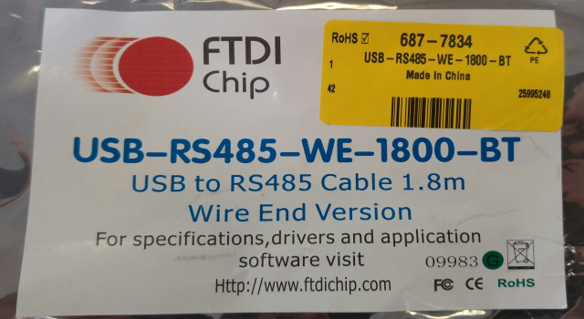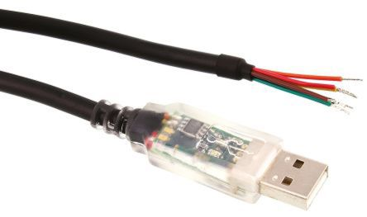

Install the driver available on the site FTDIchip.com (go in D2XX Drivers take the setup.exe)
- CDM21228_Setup.exe

Wiring
Plug DB25 M | USB-RS485  FtdiChip.com
3 - Rx/Tx (AA’) | Yellow
7 – GND | Black
16 - Rx/Tx (BB’) | Orange

To connect the end of line resistor, connect :
- Yellow and brown together
- Orange and green ensemble

Take care: Isolate the red wire because it may be connected to 5V.

Tested on NVC6000
Without End of line resistor: OK it works  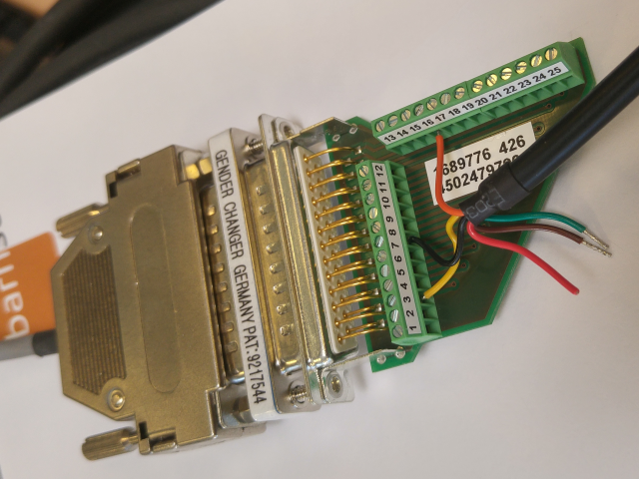 | With EOLR (wires connected together): OK it works.  